Dependency injection:

A dependency needed for an object is provided by another object or program, so that we don’t have to handle the object maintenance.

Inversion of control:

Dependencies to be injected at run time and not predetermined. The contr4ol of creating the objects is given to spring framework instead of we creating objects.

Primary Bean - @Primary:

When we have two or more implementations for an interface, then while injecting bean, the spring will not decide which one to inject, runtime error is thrown.

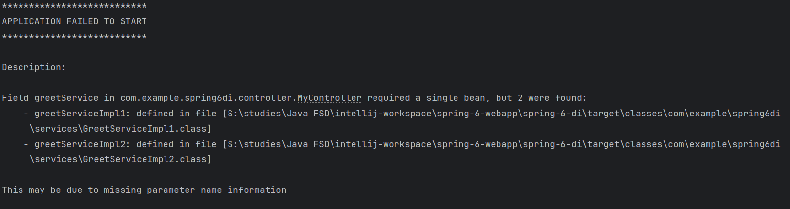

To resolve this, we can use @Primary annotation in any of the implementations so that that will be the default injection.

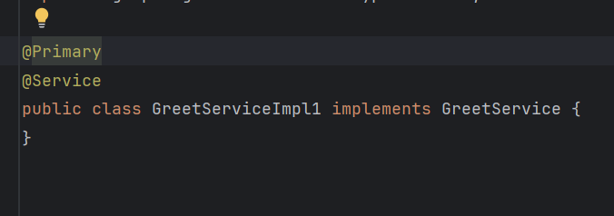

If we want the other object to be injected, we have to provide name to the bean using @Service(“beanName) and use @Qualifier(“beanName”) near @Autowired

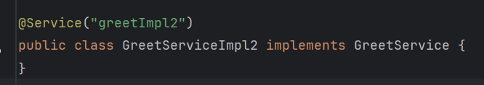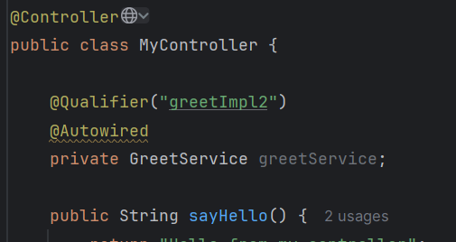

@Profile(“EN) helps us to provide spring the choice to select the beans based on the active profile of the application.

Default profile, as we know if we did not specify profile while running the default profile will be used by the spring to inject the beans.

@Profile({“EN”, “default”})